all details related to ArryList :->

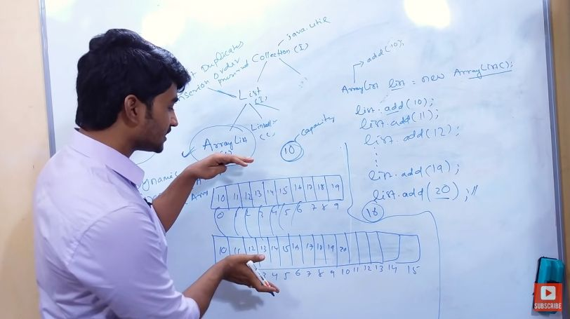

Internal Data Structure is Dynamic Array/Growable Array/Resizable Array...

1) first array will get created with default size of 10

2) when it reaches its size then new array will get created with size of [ current capacity \* 3/2 + 1]

3) then all the old data from old array gets copied to newly created Array

4) old data Array are now goes for the garbej collection...

shift operation

